Setting up an AWS RDS instance
Sign into your AWS console

Firewall (Security Groups) setup
We will first define a firewall rule to allow Dalgo to access the database you’re about to create

https://console.aws.amazon.com/ec2/home#CreateSecurityGroup

Basic Details
Start by naming your new security group

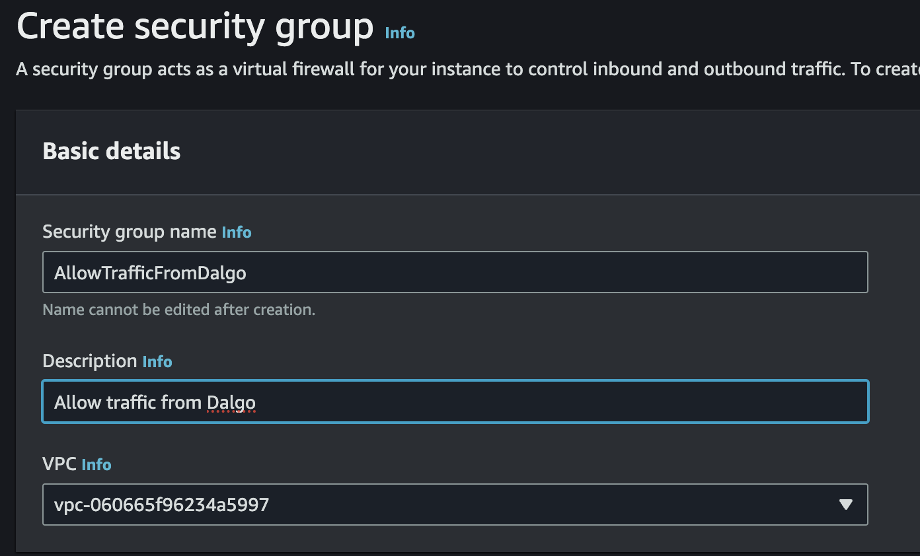

Inbound rules
Next define two inbound rules, allowing traffic on port 5432 from the two IP addresses
- 13.202.158.220
- 13.202.128.47

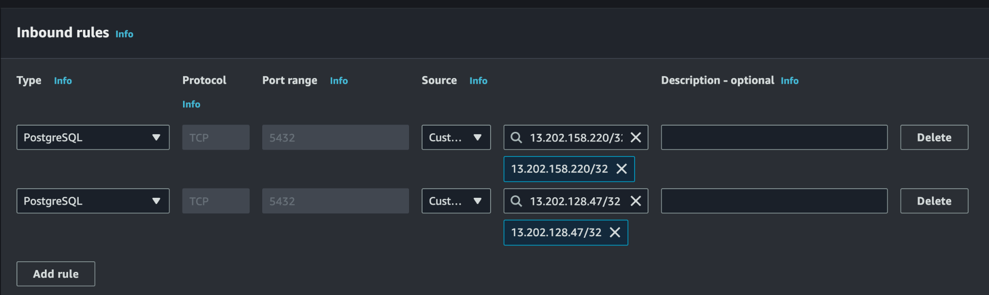

Leave the Outbound rules and Tags as they are and click “Create security group”. Make a note of the name you chose above; we will use it later.

RDS Setup
Now navigate to RDS
https://console.aws.amazon.com/rds/home

Look for and click the “Create Database” button

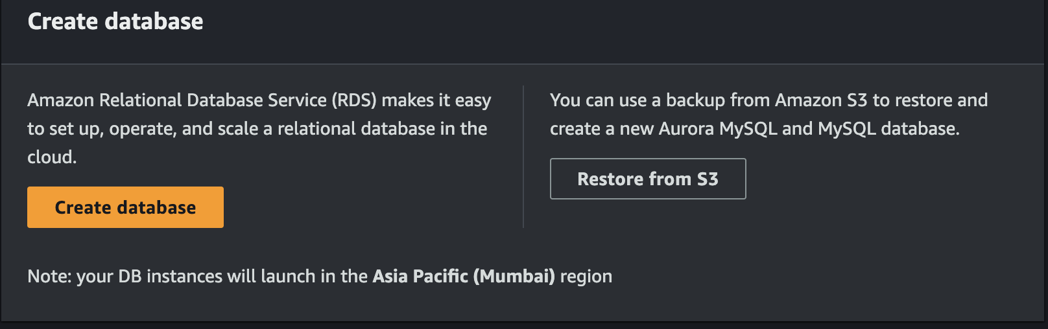

Engine
Choose Postgres as your engine

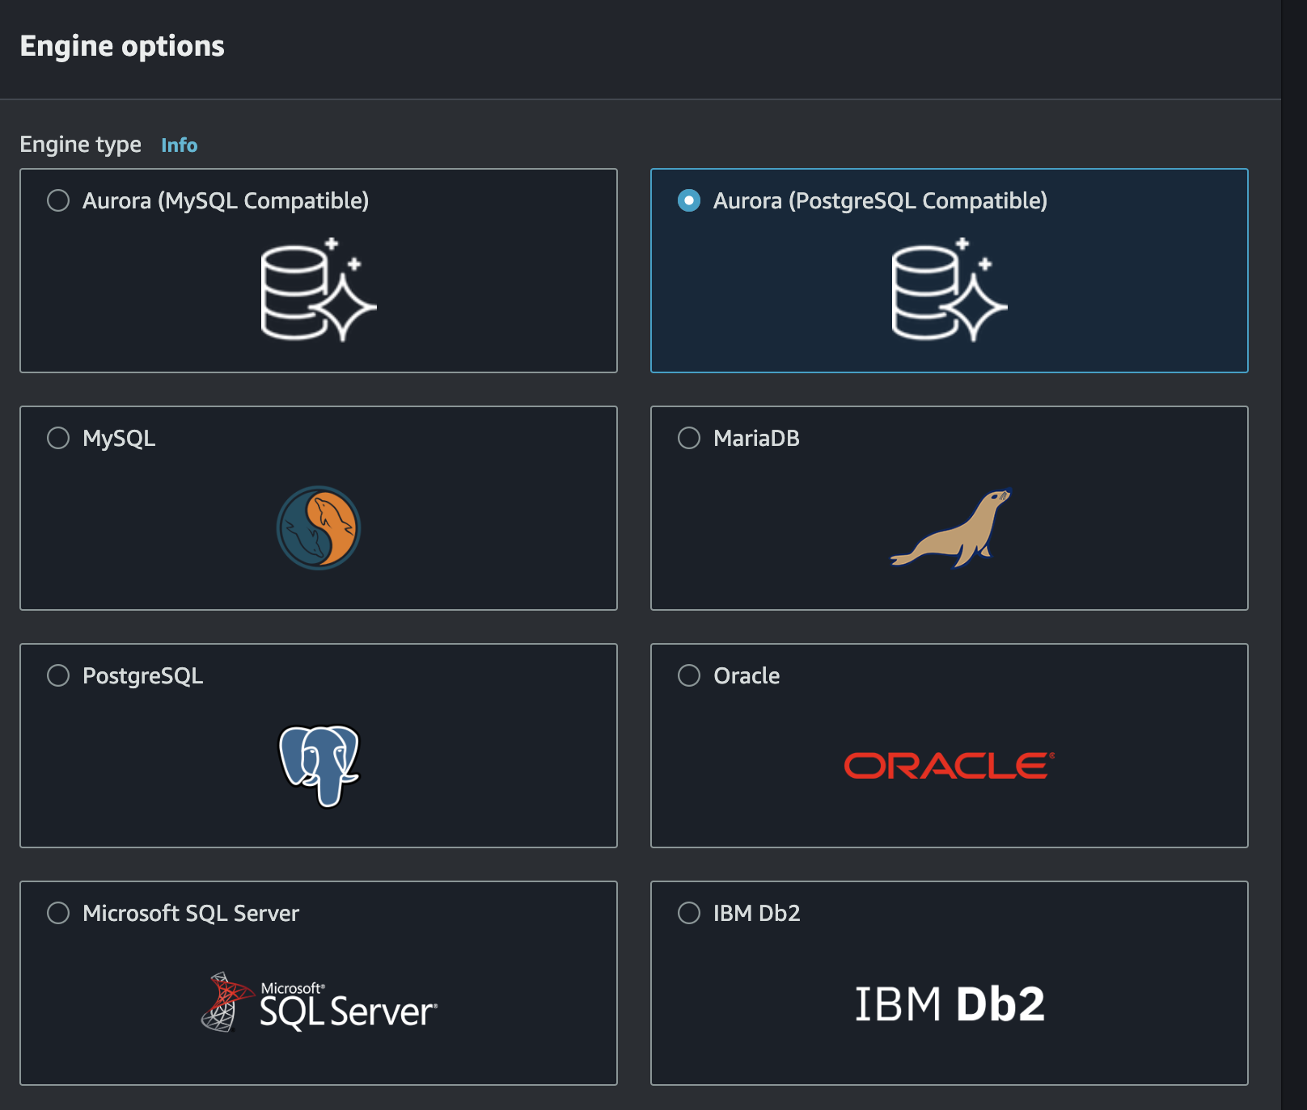

Dalgo currently recommends Postgres 15.8-R1, but any of the latest models are also recommended and supported.

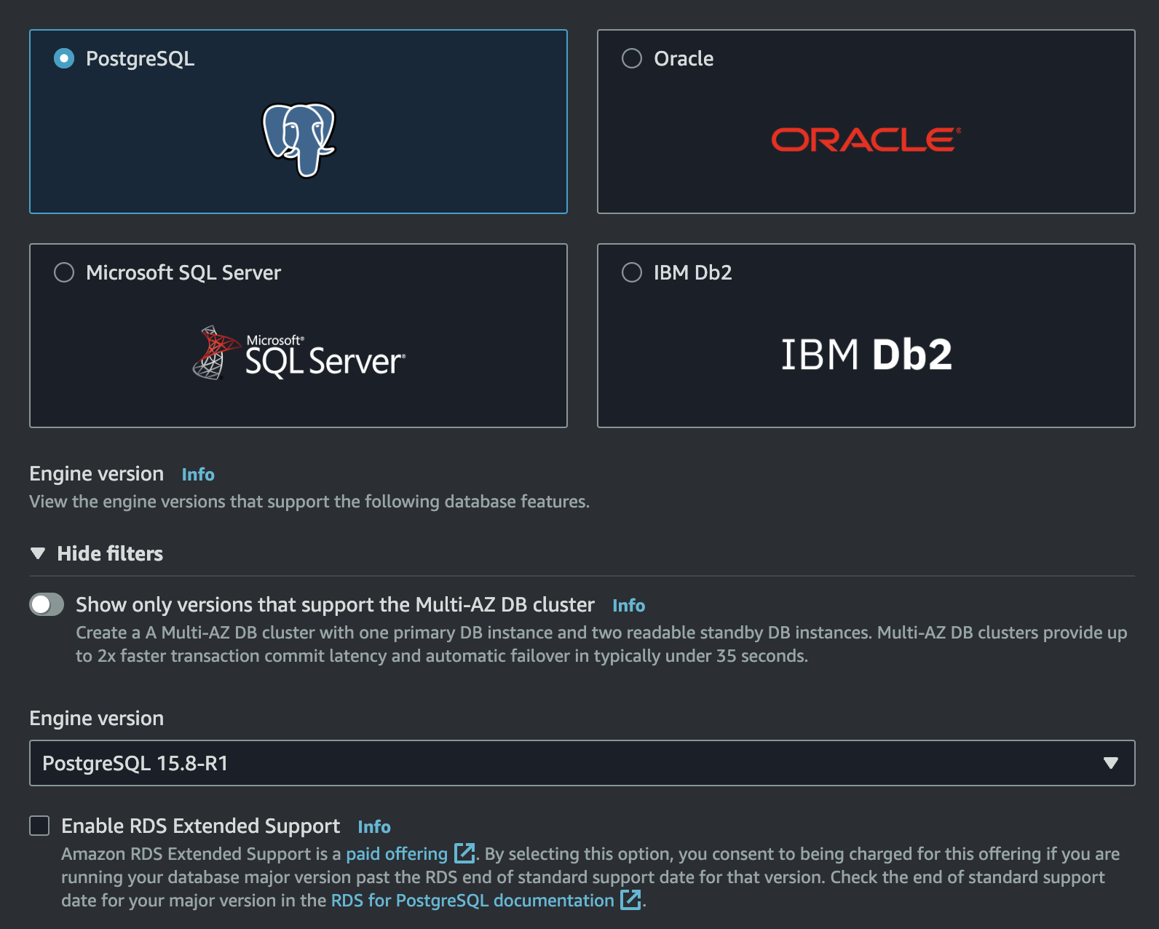

Templates
Choose the Free Tier

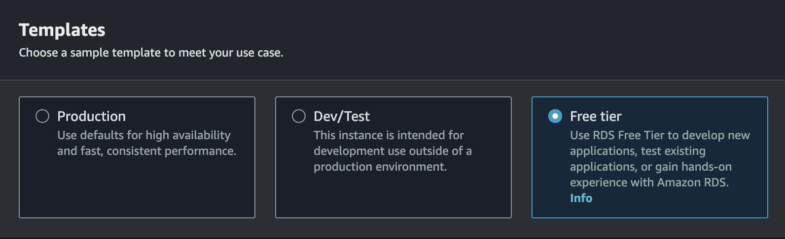

Availability and Durability
Leave it pre-selected to “Single DB Instance”

Settings
Under Settings, choose a name for your database instance. Keep the Master username as “postgres” and either choose a password or ask AWS to auto generate one for you.

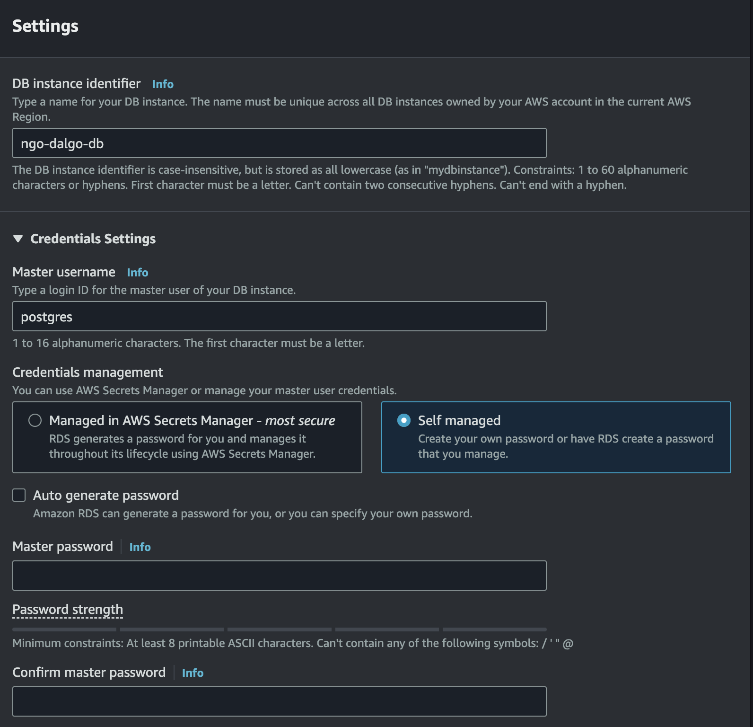

Instance configuration
Next you will choose the instance type i.e. the RAM and number of CPUs to allocate to your new database instance. We have found that the micro class works fine for Dalgo warehouses

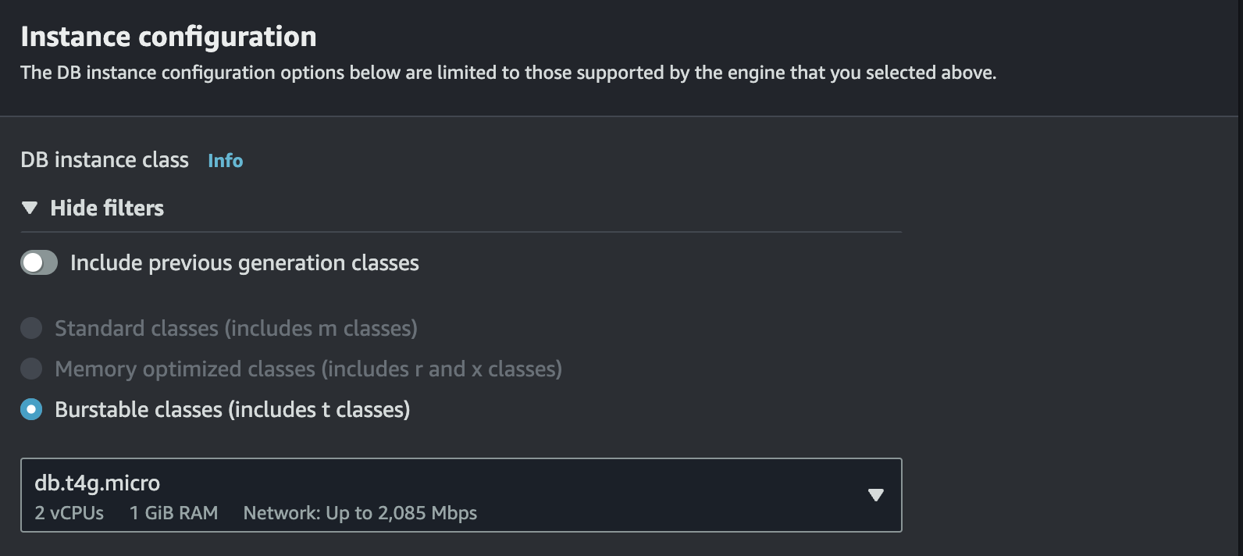

Storage
Now allocate the storage space for your database. 20GB should be sufficient to start out with, but remember to turn off auto-scaling to avoid any billing surprises

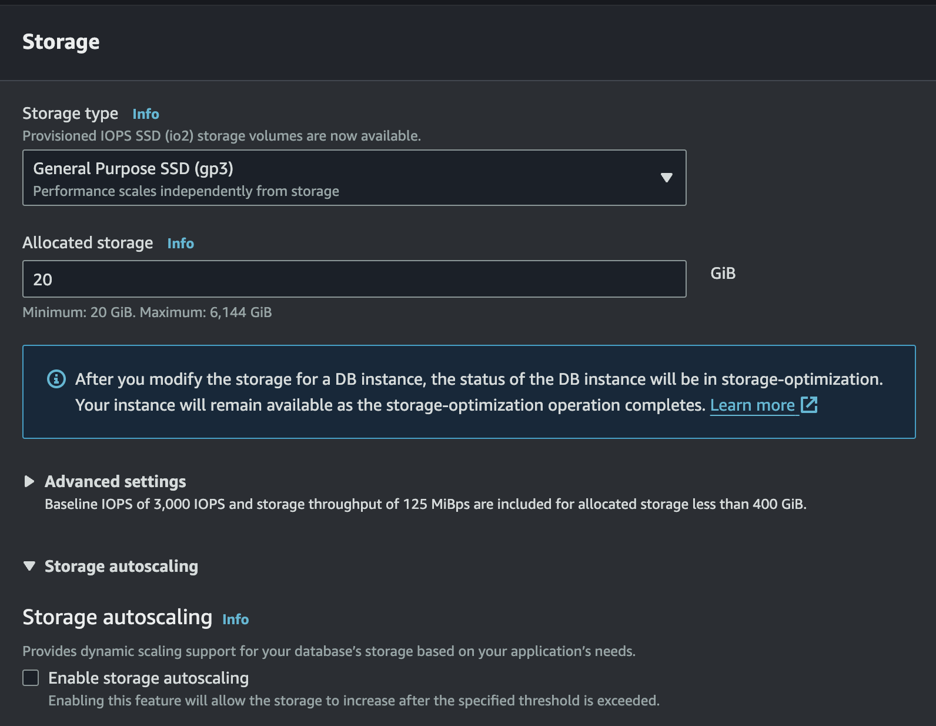

Connectivity
This is the most complicated section. The first few settings will remain unchanged

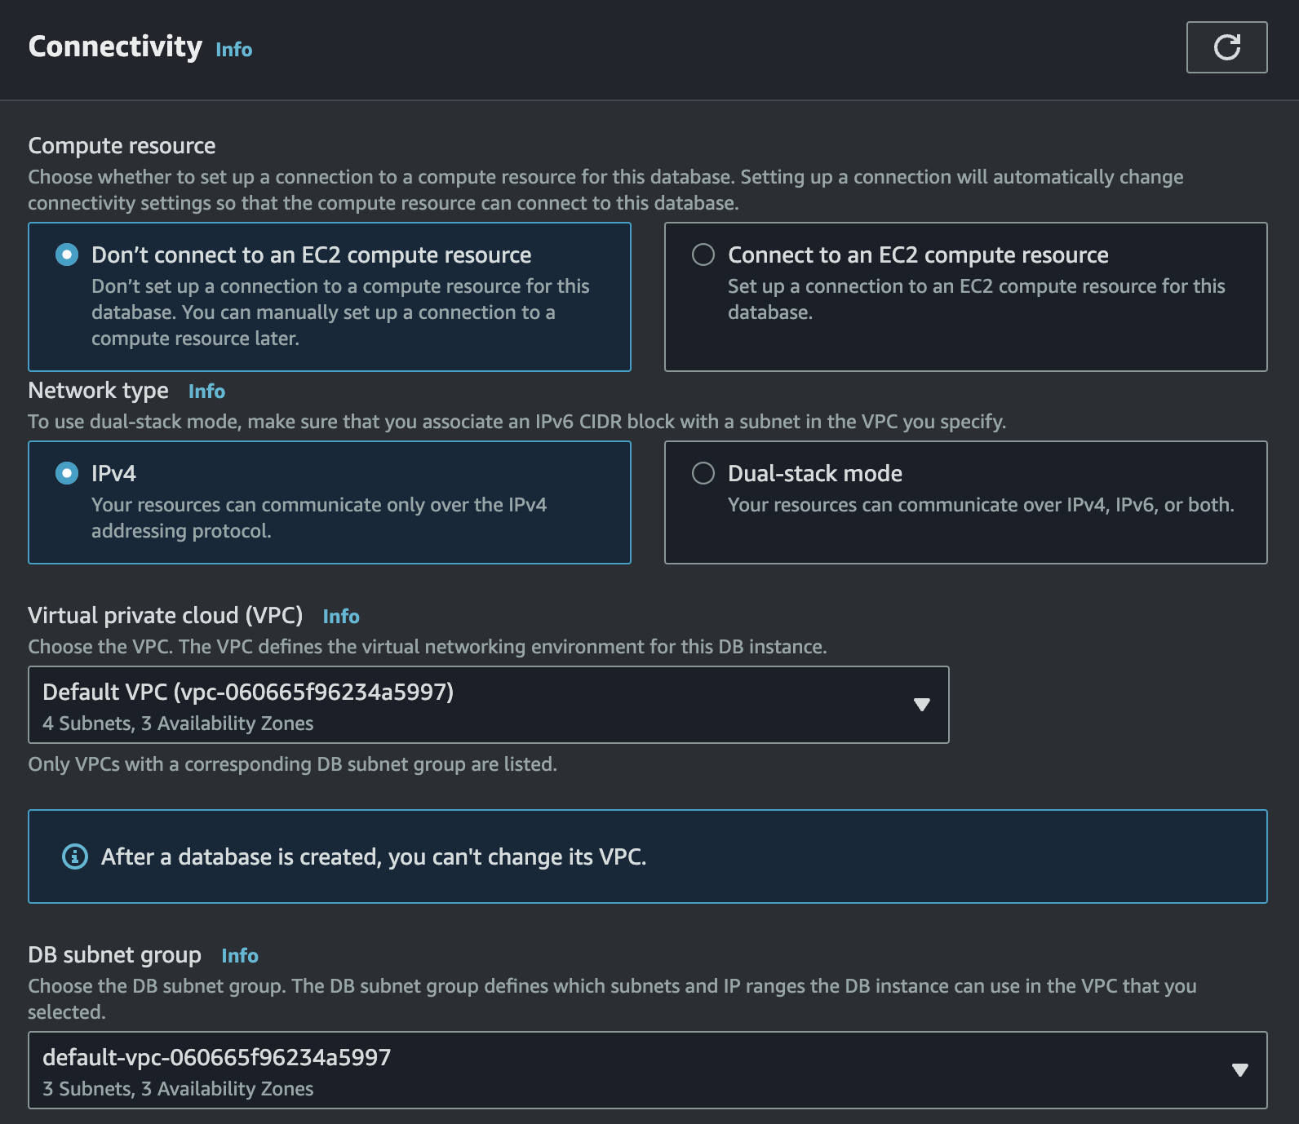

Change Public Access to Yes

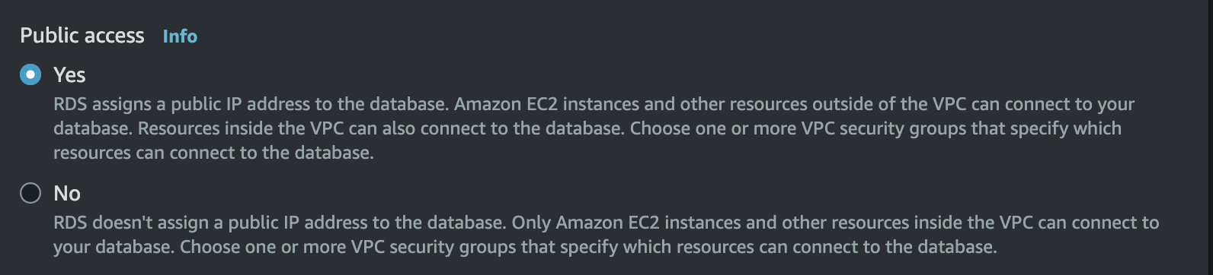

VPC Security groups

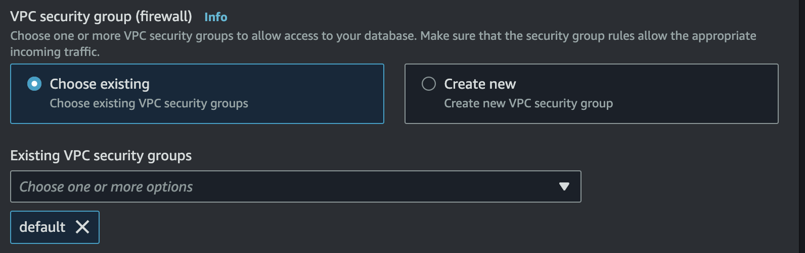

Add the security group created earlier; you will end up with “default” as well as your new security group listed here.

The remaining settings can be left unchanged
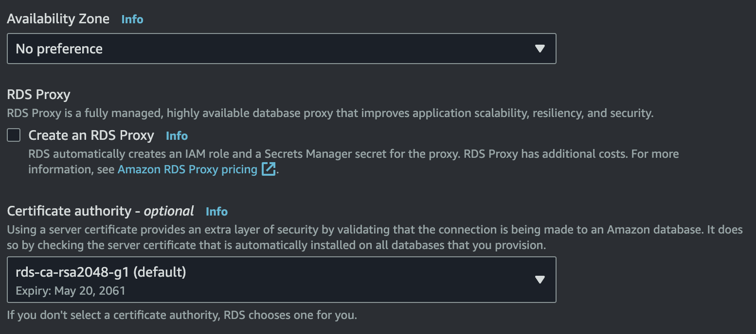

Tags
Leave unchanged

Database authentication
Leave set to “Password authentication”

Monitoring
Turn off “Performance Insights”

Review and Create
Have a look over your settings and then click the Create Database button

